SIMATS ENGINEERING
Department of Information Technology
ITA05 – Computer Vision ASSIGNMENT 1 – CO1
Assignment Title: Apply, Compare and Justify Image Acquisition, Formation and Processing
Techniques for a Textile Fabric Defect Inspection System
CO1: Apply the fundamental concepts, image formation models, and processing techniques for analyzing Computer Vision systems.
Student Name | Shaik.imran | Register Number | 192525348
Department /  Section | Information  Technology | Academic Year /  Semester | 2025–2026 / 3rd  ______
Faculty Name | p.murali | Nature of  Assignment | Individual
Duration | 1 Week | Total Marks | 50
Date of  Submission | 30.10.2026 | Date of  Evaluation | 07.11.2026

Industrial Scenario
Sri Lakshmi Textile Industries, Tiruppur, plans to develop a computer vision-based inspection system for its fabric production line. The system must inspect moving cotton and cotton-polyester fabric, measure fabric width, and identify holes, broken threads, oil stains, weaving irregularities and colour variations. It must estimate the location of each defect and trigger a marking mechanism so that the defective portion can be identified for rework or rejection.

Given Industrial Data and Constraints
Parameter | Specification
Fabric width | 1,000 mm
Camera field of view | 1,200 × 400 mm
Conveyor speed | 0.6 m/s
Smallest defect to be detected | 1.5 mm
Oil-stain contrast | 5–8 grey levels
Required fabric-width measurement accuracy | ±2 mm
Maximum decision time | 0.5 s
Distance between camera and marking mechanism | 0.3 m
Lighting variation | 500–3,000 lux
Camera mounting height | 700 mm above the fabric
Available computing system | 4-core CPU, 16 GB RAM, no GPU
Software environment | Python, OpenCV and NumPy
Network interface | Gigabit Ethernet
Storage capacity | 2 TB
Maximum project budget | ₹1,50,000
Image retention period | 7 days
Maximum acceptable missed-defect rate | 2%

General Instructions
- Answer all ten tasks.
- For every task, three candidate techniques or approaches are provided. Analyse all three alternatives, compare their suitability for the given industrial scenario, select the most appropriate option and justify your selection.
- Support your answers with calculations, diagrams, tables, observations, screenshots or experimental results wherever applicable.
- Clearly state assumptions and show the steps used in numerical calculations.
- Your justification must consider the given operating conditions, accuracy, processing time, hardware limitations and budget.
- Do not provide only definitions. Relate every answer to the textile fabric inspection application.
- Where implementation is required, use Python, OpenCV and NumPy. Include relevant code snippets and sample output.

TASK 1: Overview and Features of Computer Vision – Compare Grading/Inspection Approaches
Marks: 4
Compare the following three approaches for inspecting fabric defects:
Candidate techniques / approaches:
- Manual inspection by trained workers
- Image-processing-assisted inspection, in which an operator reviews computer-generated results
- Fully automated computer vision inspection
Student tasks:
- Explain the working principle of each approach.
- Compare their accuracy, speed, consistency, labour requirement and suitability for continuous fabric production.
- Select the most suitable approach for Sri Lakshmi Textile Industries and justify your decision using the given production conditions.
- Identify at least two limitations of your selected approach and suggest how they can be reduced.

TASK 2: Levels of Computer Vision – Pipeline Design and Operation
Marks: 5
Compare the following system designs:
Candidate techniques / approaches:
- Low-level pipeline: image acquisition, preprocessing and enhancement
- Three-level pipeline: low-level processing, intermediate-level feature extraction and high-level defect decision
- Deep-learning-based pipeline: image acquisition, neural-network inference and defect classification
Student tasks:
- Draw a block diagram for each pipeline.
- Explain the input and output of each processing stage.
- Identify the stages required to detect holes, broken threads, stains and weaving irregularities.
- Compare computational complexity, explainability, hardware requirements and response time.
- Recommend a pipeline that can operate within the available 4-core CPU system and the 0.5-second decision constraint.

TASK 3: Image Representation Analysis
Marks: 4
Compare the following image representations for fabric inspection:
Candidate techniques / approaches:
- RGB colour representation
- HSV colour representation
- Grayscale representation
Student tasks:
- Explain how each representation stores image information.
- Discuss the suitability of each representation for identifying colour variations, oil stains, holes and broken threads.
- Compare memory requirements and processing complexity.
- Choose a suitable representation or combination of representations and justify your choice with examples from the scenario.

TASK 4: Connectivity Analysis
Marks: 4
Compare the following pixel-connectivity approaches for identifying defect regions:
Candidate techniques / approaches:
- 4-connectivity
- 8-connectivity
- m-connectivity (mixed connectivity)
Student tasks:
- Define each connectivity approach with a suitable pixel-neighbour diagram.
- For a small binary image containing diagonally and horizontally connected defect pixels, identify the connected components using all three methods.
- Explain how the choice of connectivity may affect defect-region size and component counting.
- Recommend the most appropriate connectivity method for detecting small holes and irregular fabric defects.

TASK 5: Image Acquisition Analysis
Marks: 5
Compare the following camera acquisition options for the moving fabric line:
Candidate techniques / approaches:
- Rolling-shutter camera
- Global-shutter camera
- Line-scan camera
Student tasks:
- Explain the image acquisition principle of each camera type.
- Analyse the effect of fabric movement at 0.6 m/s on image distortion and defect visibility.
- Compare image quality, suitability for continuous web inspection, installation complexity and cost.
- Select a camera type for the given fabric width and production process.
- Justify the selection with reference to the 1.5 mm minimum defect size and 0.5-second decision requirement.

TASK 6: Sampling Analysis
Marks: 5
Evaluate the following image sampling resolutions:
Candidate techniques / approaches:
- Low resolution: 1280 × 1024 pixels
- Medium resolution: 2448 × 2048 pixels
- High resolution: 4096 × 3000 pixels
Student tasks:
- Calculate the total number of pixels for each resolution.
- Estimate the approximate spatial sampling interval across the 1,200 mm field of view, assuming the image width corresponds to the full field-of-view width.
- Determine whether a 1.5 mm defect can be represented adequately at each resolution.
- Compare image storage, processing time and defect-detection capability.
- Select a resolution that balances defect visibility and the available computing resources. Show all calculations.

TASK 7: Quantization Analysis
Marks: 4
Compare the following intensity quantization options:
Candidate techniques / approaches:
- 8-bit quantization
- 12-bit quantization
- Reduced 4–6 bit quantization
Student tasks:
- Calculate the number of intensity levels available in each option.
- Explain how quantization affects the representation of low-contrast oil stains having only 5–8 greylevel differences.
- Compare image storage requirements and processing implications.
- Recommend a quantization level for reliable defect detection under the stated lighting conditions. Justify your answer.

TASK 8: Image Formation Analysis
Marks: 5
Compare the following image formation and calibration approaches:
Candidate techniques / approaches:
- Standard perspective imaging without calibration
- Calibrated imaging with geometric correction
- Controlled-illumination imaging with suitable calibration
Student tasks:
- Explain the image formation process for a camera mounted 700 mm above the fabric.
- Discuss perspective distortion and its effect on fabric-width measurement.
- Explain how camera calibration can improve measurement accuracy.
- Analyse how lighting variation from 500 to 3,000 lux can affect defect visibility.
- Recommend an image formation and illumination arrangement that can achieve the required width accuracy of ±2 mm.

TASK 9: Implementation and Performance Evaluation
Marks: 6
Design and compare three complete implementation configurations:
Candidate techniques / approaches:
- Budget configuration: minimum-cost camera, basic illumination and CPU-based processing
- Balanced configuration: suitable camera, controlled illumination and optimised CPU-based processing
- Premium configuration: high-resolution industrial camera, advanced illumination and higherperformance processing hardware
Student tasks:
- Prepare a block diagram showing camera, illumination, processing unit, storage, network and marking mechanism.
- Prepare a comparison table covering estimated cost, resolution, processing time, storage and expected inspection capability.
- Explain how the system will detect and record holes, broken threads, stains and weaving irregularities.
- Describe how the system will communicate the defect location to the marking mechanism located
0.3 m downstream.
- Evaluate whether each configuration can meet the 0.5-second decision time, 7-day image retention and 2% maximum missed-defect rate.
- Select one configuration that fits the ₹1,50,000 budget and justify your selection. Clearly state any assumptions used in cost estimates.

TASK 10: Front-End Adaptation Challenge
Marks: 8
Assume that the textile company receives a new export order with the following changed requirements: the system must detect defects as small as 0.4 mm, identify stains visible under ultraviolet (UV) illumination, operate at a conveyor speed of 1.2 m/s, inspect twice the current production volume and produce a decision within 0.3 seconds. The existing PC and project budget must remain unchanged.
Candidate techniques / approaches:
- Retain the existing system with only software changes
- Modify the existing system by upgrading selected components
- Redesign the inspection system using a different acquisition and processing architecture
Student tasks:
- Identify which existing system components will become inadequate under the new requirements.
- Analyse the effect of the increased conveyor speed and smaller defect size on image sampling and acquisition.
- Explain how UV illumination or an additional imaging channel could help identify the new stain type.
- Compare the three adaptation strategies in terms of feasibility, accuracy, processing time, cost and implementation risk.
- Recommend the most practical strategy under the unchanged PC and budget constraints.
- Prepare an updated system block diagram and list the changes required.
- Clearly identify any requirements that cannot realistically be achieved without additional resources, and justify your conclusion.

Mark Distribution
Task | Topic | Marks
1 | Overview and Features of Computer Vision | 4
2 | Levels of Computer Vision | 5
3 | Image Representation | 4
4 | Connectivity Analysis | 4
5 | Image Acquisition | 5
6 | Sampling Analysis | 5
7 | Quantization Analysis | 4
8 | Image Formation | 5
9 | Implementation and  Performance Evaluation | 6
10 | Front-End Adaptation Challenge | 8
 | TOTAL | 50

Submission Requirements
- Submit a neatly formatted assignment report with task-wise headings.
- Include hand-drawn or computer-generated diagrams wherever required.
- Show all numerical calculations with formulae, substitution and final units.
- Include comparison tables and evidence supporting the selected techniques.
- For implementation tasks, attach source code, sample input images and output screenshots.
- Mention references, tools and software libraries used.

TASK 1 – Overview and Features of Computer Vision
4 Marks
1. Working principle of each inspection approach
1. Manual inspection by trained workers
- Fabric is examined visually by trained workers.
- Workers identify holes, broken threads, stains and weaving irregularities.
- Defects are identified using human observation and experience.
- Defective portions are marked manually.
2. Image-processing-assisted inspection
- A camera captures images of the moving fabric.
- Image-processing algorithms enhance the image and identify possible defects.
- The system displays the detected regions to an operator.
- The operator verifies the results and makes the final decision.
3. Fully automated computer vision inspection
- Industrial cameras continuously capture fabric images.
- Computer vision algorithms automatically detect and classify defects.
- The system records defect locations and sends signals to a marking mechanism.
- Minimal human intervention is required.

2. Comparison of inspection approaches
Parameter | Manual | Assisted | Fully automated
Accuracy | Depends on worker | High | High with proper calibration
Speed | Slow | Medium | Very high
Consistency | Variable | Moderate to high | High
Labour | High | Medium | Low
Continuous production | Less suitable | Moderately suitable | Highly suitable

3. Most suitable approach
Recommended: Fully automated computer vision inspection.
Justification:
- Sri Lakshmi Textile Industries requires continuous fabric inspection.
- The production speed is 0.6 m/s.
- The system must detect defects as small as 1.5 mm.
- The decision must be generated within 0.5 seconds.
- Automated inspection reduces human errors and labour requirements.
- It provides consistent inspection and automatic defect marking.

4. Limitations and solutions
Limitation | Suggested solution
Incorrect defect detection | Improve image preprocessing and algorithm training
Lighting variations | Install controlled LED illumination
Camera calibration errors | Perform regular camera calibration
High processing requirements | Use optimised CPU-based algorithms
Conclusion: Fully automated computer vision is the most suitable approach for continuous and reliable textile inspection.

TASK 2 – Levels of Computer Vision
5 Marks
1. Block diagrams of three pipelines
A. Low-level pipeline
Image Acquisition
Image Preprocessing
Image Enhancement
Enhanced Image
B. Three-level pipeline
Image Acquisition
Low-level Processing
Intermediate-level Feature Extraction
High-level Defect Decision
Defect Classification and Location
C. Deep-learning-based pipeline
Image Acquisition
Image Preprocessing
Neural Network Inference (CNN)
Defect Classification
Defect Decision
2. Input and output of each stage
Stage | Input | Output
Image acquisition | Fabric | Digital image
Preprocessing | Raw image | Noise-reduced image
Enhancement | Preprocessed image | Improved contrast image
Feature extraction | Enhanced image | Edges, texture and colour features
Defect decision | Extracted features | Defect or normal classification
CNN inference | Image pixels | Predicted defect class

3. Stages required for defect detection
Defect | Required processing
Holes | Thresholding, edge detection and connected components
Broken threads | Edge detection and texture analysis
Stains | Colour analysis and intensity thresholding
Weaving irregularities | Texture analysis and pattern comparison

4. Comparison of pipelines
Parameter | Low-level | Three-level | Deep learning
Complexity | Low | Medium | High
Explainability | High | High | Relatively low
Hardware | Basic CPU | 4-core CPU suitable with optimisation | GPU preferred for demanding models
Response time | Fast | Fast to moderate | Model dependent
Accuracy | Limited | Good | Potentially very high

5. Recommended pipeline
Recommended: Three-level computer vision pipeline.
Reasons:
- It can operate on the available 4-core CPU.
- It provides understandable processing stages.
- It supports hole, stain, thread and texture detection.
- It can be optimised to meet the 0.5-second decision constraint.
- It does not require expensive GPU hardware.
Conclusion: The three-level pipeline provides a suitable balance between accuracy, processing time and hardware requirements.
TASK 3 – Image Representation Analysis
4 Marks
1. Explanation of image representations
A. RGB representation
- RGB stands for Red, Green and Blue.
- Each pixel stores three colour components.
- It represents the original colour information of the fabric.
- It is useful for identifying different coloured stains.
B. HSV representation
- HSV stands for Hue, Saturation and Value.
- Hue represents colour type.
- Saturation represents colour intensity.
- Value represents brightness.
- It separates colour information from brightness information.
C. Grayscale representation
- Each pixel contains only one intensity value.
- It represents the image using shades of grey.
- It is useful for detecting structural defects and intensity variations.

2. Suitability for fabric defects
Defect | RGB | HSV | Grayscale
Colour variations | Excellent | Excellent | Limited
Oil stains | Good | Very good | Good if contrast exists
Holes | Good | Good | Excellent with suitable lighting
Broken threads | Good | Good | Excellent
Weaving irregularities | Good | Good | Excellent

3. Memory and processing comparison
Assuming 8-bit storage per channel:
Representation | Bits per pixel | Relative memory | Complexity
RGB | 24 bits | High | Medium
HSV | 24 bits | High | Medium to high
Grayscale | 8 bits | Low | Low
Grayscale requires approximately one-third of the memory of 8-bit-per-channel RGB.

4. Recommended representation
Recommended: Combination of RGB, HSV and Grayscale.
- Use RGB for original colour information.
- Use HSV to identify oil stains and colour variations.
- Use grayscale for holes, broken threads and weaving irregularities.
For example, a dark oil stain can be identified through HSV colour and saturation differences, while a broken thread can be detected through grayscale edge and texture analysis.
Conclusion: A combination of colour and grayscale representations provides better defect-detection capability than relying on a single representation.

TASK 4 – Connectivity Analysis
4 Marks
1. Definition of connectivity approaches
A. 4-connectivity
A pixel is connected to its four horizontal and vertical neighbours.
Four direct neighbours of the centre pixel.
B. 8-connectivity
A pixel is connected to all eight surrounding neighbours, including diagonal neighbours.
All eight surrounding pixels are considered neighbours.
C. m-connectivity (mixed connectivity)
- It combines 4-connectivity and selected diagonal connections.
- Diagonal pixels are considered connected only when their common 4-neighbours do not belong to the foreground set.
- It avoids ambiguous multiple connections.

2. Connected-component example
Consider the following binary image:
1 1 0
0 1 0
0 0 1
Here, 1 represents a defect pixel and 0 represents the background.
Method | Connected components | Explanation
4-connectivity | 2 | Diagonal-only connection is not allowed
8-connectivity | 1 | Diagonal connections are allowed
m-connectivity | 1 | The diagonal connection between (2,2) and (3,3) is permitted
3. Effect of connectivity
- 4-connectivity may divide one diagonal defect into multiple components.
- 8-connectivity may combine nearby diagonal defects.
- m-connectivity avoids unnecessary diagonal connections when common neighbouring pixels already provide a connection.
- Connectivity influences defect-region size and component counting.
4. Recommended method
Recommended: 8-connectivity for small and irregular fabric defects.
Reasons:
- Fabric defects may have irregular shapes.
- Small holes and diagonal broken threads must be connected correctly.
- It reduces the possibility of splitting diagonal defect regions.
m-connectivity is a useful alternative when ambiguous diagonal connections need to be controlled.
Conclusion: 8-connectivity is suitable for identifying irregular defect regions in textile images.

TASK 5 – Image Acquisition Analysis
5 Marks

1. Working principle of camera types
A. Rolling-shutter camera
- Captures an image row by row.
- Different rows are exposed at slightly different times.
- Fast-moving fabric may produce geometric distortion.
B. Global-shutter camera
- All pixels capture the image at approximately the same time.
- It reduces motion-related geometric distortion.
- It is suitable for capturing moving objects.
C. Line-scan camera
- Captures one line of pixels at a time.
- Multiple lines are combined to construct a complete image.
- It is designed for continuous moving materials such as fabric, paper and metal sheets.

2. Effect of fabric movement
Given:
- Fabric speed = 0.6 m/s
- Fabric speed = 600 mm/s
If the exposure time is 1 ms:
\[ \text{Motion blur}=600\times0.001 \]
\[ =0.6\text{ mm} \]
This blur can reduce the visibility of a 1.5 mm defect.
A shorter exposure time and sufficient illumination help reduce motion blur.

3. Comparison
Parameter | Rolling shutter | Global shutter | Line scan
Image quality | Motion distortion possible | Good | Excellent for continuous webs
Continuous inspection | Moderate | Good | Excellent
Installation | Easy | Moderate | More complex
Cost | Low to medium | Medium to high | Medium to high
Motion distortion | Higher risk | Low | Controlled by line timing

4. Recommended camera
Recommended: Industrial line-scan camera.
Reasons:
- Fabric is a continuously moving web.
- Line-scan cameras are suitable for inspecting wide fabric surfaces.
- They provide continuous image acquisition.
- They can detect small defects across the fabric width.

5. Justification
The minimum defect size is 1.5 mm.
The camera must provide sufficient spatial resolution to represent this defect with multiple pixels.
For example, a sampling interval of approximately 0.49 mm/pixel provides:
\[ \frac{1.5}{0.49}\approx3.06\text{ pixels} \]
This is a reasonable minimum for basic defect detection, although finer sampling is preferable.
The image-processing system must also complete the decision within 0.5 seconds.
Conclusion: A line-scan camera with controlled illumination and optimised processing is the most suitable choice.

TASK 6 – Sampling Analysis
5 Marks
1. Calculate total pixels
Formula:
\[ \text{Total pixels}=\text{Width}\times\text{Height} \]
A. Low resolution
\[ 1280\times1024=1,310,720 \]
Total = 1.31 megapixels
B. Medium resolution
\[ 2448\times2048=5,013,504 \]
Total = 5.01 megapixels
C. High resolution
\[ 4096\times3000=12,288,000 \]
Total = 12.29 megapixels

2. Calculate spatial sampling interval
Given:
- Fabric field of view = 1200 mm
- Image width represents the complete fabric width.
Formula:
\[ \text{Sampling interval}= \frac{\text{Field of View}}{\text{Image Width}} \]
A. Low resolution
\[ =\frac{1200}{1280} =0.9375\text{ mm/pixel} \]
B. Medium resolution
\[ =\frac{1200}{2448} =0.4902\text{ mm/pixel} \]
C. High resolution
\[ =\frac{1200}{4096} =0.2930\text{ mm/pixel} \]

3. Can a 1.5 mm defect be detected?
Formula:
\[ \text{Pixels covering defect}= \frac{\text{Defect size}}{\text{Sampling interval}} \]
Low resolution:
\[ \frac{1.5}{0.9375}=1.6\text{ pixels} \]
Medium resolution:
\[ \frac{1.5}{0.4902}=3.06\text{ pixels} \]
High resolution:
\[ \frac{1.5}{0.2930}=5.12\text{ pixels} \]

4. Comparison table
Parameter | Low | Medium | High
Resolution | 1280 × 1024 | 2448 × 2048 | 4096 × 3000
Total pixels | 1.31 MP | 5.01 MP | 12.29 MP
Sampling interval | 0.9375 mm | 0.4902 mm | 0.2930 mm
Pixels for 1.5 mm defect | 1.6 | 3.06 | 5.12
Storage | Low | Medium | High
Processing time | Low | Medium | High
Defect visibility | Limited | Good | Very good

5. Recommended resolution
Recommended: Medium resolution
Reasons:
- It provides approximately 3 pixels across a 1.5 mm defect.
- It requires less processing than high resolution.
- It is more suitable for the 4-core CPU.
- It balances image quality and processing time.
High resolution offers better defect visibility but increases processing and storage requirements.
Conclusion: The 2448 × 2048 resolution is the practical choice under the original production conditions.

TASK 7 – Quantization Analysis
4 Marks
1. Calculate intensity levels
Formula:
\[ \text{Intensity levels}=2^n \]
Where \(n\) is the number of bits.
A. 8-bit quantization
\[ 2^8=256\text{ levels} \]
B. 12-bit quantization
\[ 2^{12}=4096\text{ levels} \]
C. Reduced quantization
For 4-bit:
\[ 2^4=16\text{ levels} \]
For 6-bit:
\[ 2^6=64\text{ levels} \]

2. Effect on low-contrast oil stains
Oil stains have only 5–8 grayscale-level differences.
- 8-bit quantization provides 256 intensity levels and can preserve these differences when the camera and lighting have sufficient signal quality.
- 12-bit quantization provides more intensity levels and can preserve subtle variations.
- 4–6-bit quantization may merge small intensity differences, making stains difficult to detect.

3. Comparison
Parameter | 4–6 bit | 8 bit | 12 bit
Intensity levels | 16–64 | 256 | 4096
Memory | Very low | Medium | High
Processing | Fast | Fast | Higher data handling
Low-contrast stains | Poor | Good | Very good
Detail preservation | Low | Good | High

4. Recommended quantization
Recommended: 12-bit image acquisition with 8-bit processing where appropriate.
Reasons:
- It preserves subtle intensity differences.
- It improves the representation of low-contrast oil stains.
- It provides additional dynamic range under controlled lighting.
- The image can be converted to 8-bit after suitable enhancement for faster CPU processing.
However, 12-bit acquisition is useful only if the sensor and illumination provide adequate signal-to-noise performance.
Conclusion: 12-bit acquisition provides better information preservation, while optimised 8-bit processing helps reduce computational requirements.

TASK 8 – Image Formation Analysis
5 Marks
1. Image formation process
The camera is mounted 700 mm above the moving fabric.
The image formation process involves:
- Light from the illumination source falls on the fabric.
- The fabric reflects light towards the camera.
- The camera lens focuses the reflected light.
- The image sensor converts the light into digital pixel values.
- Image-processing algorithms analyse the captured image.

2. Perspective distortion
Perspective distortion occurs when objects at different positions appear with different sizes or shapes in the captured image.
Effects:
- Fabric edges may appear displaced.
- Width measurements may become inaccurate.
- Defect sizes may appear different depending on their position.
- Uneven camera alignment may introduce measurement errors.

3. Camera calibration
Camera calibration determines the relationship between image pixels and real-world measurements.
It helps to:
- Correct lens distortion.
- Correct perspective distortion.
- Convert pixel coordinates into millimetres.
- Improve fabric-width measurement.
- Maintain measurement consistency.
A calibration target with known dimensions can be used to establish the pixel-to-millimetre relationship.

4. Effect of lighting variation
Given lighting variation:
\[ 500\text{ lux to }3000\text{ lux} \]
This represents a sixfold difference in illumination.
Effects:
- Low illumination may hide small defects.
- High illumination may create glare and overexposure.
- Uneven illumination may create false defects.
- Contrast differences may affect stain detection.

5. Recommended arrangement
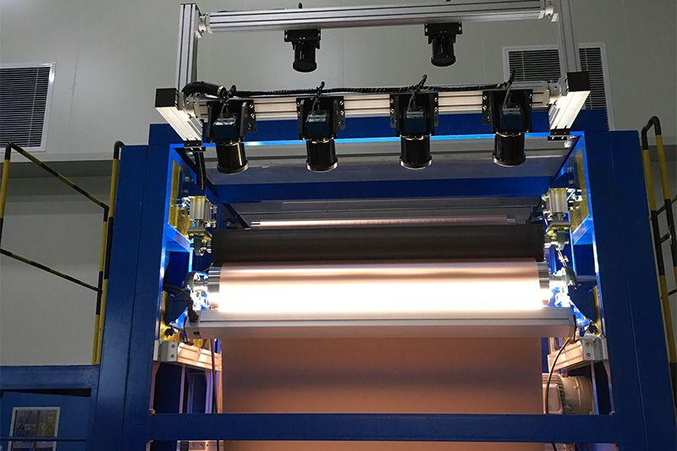
Recommended: Controlled illumination with calibrated imaging.
- Mount the camera securely at 700 mm.
- Use uniform industrial LED illumination.
- Use diffused lighting to reduce glare.
- Apply dark-field lighting where useful for thread and surface defects.
- Calibrate the camera using a known measurement target.
- Maintain constant exposure and illumination.
Conclusion: Controlled illumination and geometric calibration can improve defect visibility and help achieve the required fabric-width measurement accuracy of ±2 mm, subject to validation.

TASK 9 – Implementation and Performance Evaluation
6 Marks
1. Complete system block diagram
Moving Fabric
Industrial Camera + LED Illumination
Image Processing Unit (4-Core CPU)
Defect Detection and Classification
Storage
Images and defect records
Network
Monitoring and reports
Marking Mechanism

2. Comparison of implementation configurations
The following are illustrative planning estimates, not supplier quotations.
Parameter | Budget | Balanced | Premium
Estimated cost | ₹70,000–₹90,000 | ₹1,25,000–₹1,50,000 | ₹2,50,000+
Resolution | 1280 × 1024 | 2448 × 2048 | 4096 × 3000
Camera | Basic industrial camera | Suitable industrial line-scan camera | High-resolution line-scan camera
Illumination | Basic LED | Controlled LED | Advanced multi-angle LED
Processing | Basic CPU | Optimised 4-core CPU | Higher-performance hardware
Processing time | Variable | Target ≤0.5 sec | Potentially faster
Defect detection | Limited | Good | Very good
Storage | Basic | Dedicated storage | High-capacity storage

3. Defect detection and recording
The system uses the following methods:
Defect | Detection method
Holes | Thresholding and connected-component analysis
Broken threads | Edge detection and texture analysis
Stains | RGB/HSV colour analysis
Weaving irregularities | Texture and pattern analysis
After detection, the system records:
- Defect type.
- Defect location.
- Date and time.
- Defect size.
- Captured defect image.
- Inspection result.

4. Communication with marking mechanism
Given:
- Distance between camera and marking mechanism = 0.3 m
- Fabric speed = 0.6 m/s
Formula:
\[ t=\frac{\text{Distance}}{\text{Speed}} \]
\[ t=\frac{0.3}{0.6}=0.5\text{ seconds} \]
Therefore, the marking mechanism receives the defect location and marking signal based on the fabric's encoder position.
An encoder should track fabric movement and compensate for communication and actuator delays.
Important: A 0.5-second decision time uses the entire nominal travel time. In practice, the system must decide faster than 0.5 seconds to allow time for communication and marking.

5. Performance evaluation
Requirement | Budget | Balanced | Premium
0.5-second decision | Uncertain | Target achievable after testing | Likely achievable with suitable design
7-day image retention | Limited | Achievable with adequate storage | Achievable
Maximum 2% missed defects | Not guaranteed | Must be validated | Better potential, not guaranteed
Continuous inspection | Limited | Suitable | Highly suitable
Cost limit | Yes | Yes, at upper budget | No
A 2% missed-defect rate means the system must detect at least 98% of the relevant defects in a representative validation test.

6. Storage calculation
For medium resolution, assuming 8-bit grayscale:
\[ 2448\times2048\times1 =5,013,504\text{ bytes} \]
Approximately 5 MB per uncompressed image.
For seven days at one image per second:
\[ 7\times24\times60\times60=604800 \]
\[ 604800\times5\text{ MB} =3,024,000\text{ MB} \]
Approximately 3.02 TB of uncompressed storage.
Therefore, image compression, selective image retention and adequate storage capacity are necessary.
For example, retaining defect images, cropped defect regions and periodic normal images can significantly reduce storage requirements. The actual capacity must be calculated from the selected capture rate and compression ratio.

7. Recommended configuration
Recommended: Balanced configuration
Budget: ₹1,50,000
Illustrative budget allocation:
Component | Estimated cost
Industrial camera | ₹40,000
LED illumination | ₹12,000
Lens and mounting | ₹10,000
Storage | ₹15,000
Encoder and marking interface | ₹15,000
Mechanical installation | ₹10,000
Software development | ₹25,000
Calibration and testing | ₹8,000
Contingency | ₹15,000
Total | ₹1,50,000
Justification:
- Provides sufficient image resolution for the original 1.5 mm defect requirement.
- Uses the existing 4-core CPU efficiently.
- Supports controlled illumination.
- Allows defect recording and automatic marking.
- Fits the available budget.
Conclusion: The balanced configuration is the most practical choice, provided the processing-time, storage and missed-defect requirements are verified during commissioning.

TASK 10 – Front-End Adaptation Challenge
8 Marks
1. Identify inadequate components
The new export order introduces the following requirements:
Parameter | Existing requirement | New requirement
Minimum defect size | 1.5 mm | 0.4 mm
Fabric speed | 0.6 m/s | 1.2 m/s
Production volume | Current | 2 times
Decision time | 0.5 seconds | 0.3 seconds
Illumination | Visible light | Visible + UV
PC | 4-core CPU | Unchanged
Budget | ₹1,50,000 | Unchanged
The following components may become inadequate:
- Camera: Existing medium-resolution camera may not detect 0.4 mm defects reliably.
- Illumination: Normal LED lighting cannot identify all UV-visible stains.
- Processing unit: The 4-core CPU may struggle with increased image data.
- Storage: Twice the production volume requires additional storage capacity.
- Communication: The marking mechanism needs faster defect-location communication.

2. Effect of increased speed and smaller defects
The new defect size is 0.4 mm.
For reliable detection, assume at least 3 pixels across the defect.
\[ \text{Required sampling interval}= \frac{0.4}{3} \]
\[ =0.1333\text{ mm/pixel} \]
For a fabric width of 1200 mm:
\[ \text{Required image width}= \frac{1200}{0.1333} \]
\[ \boxed{9000\text{ pixels approximately}} \]
For better detection, 5 pixels across the defect would require:
\[ \frac{1200}{0.4/5}=15000\text{ pixels} \]
Therefore, the existing 2448-pixel-wide image is insufficient for reliable detection of the new defect size.
In addition, the fabric speed increases from 0.6 m/s to 1.2 m/s. The image acquisition rate must also increase to maintain adequate sampling along the direction of movement.

3. Use of UV illumination
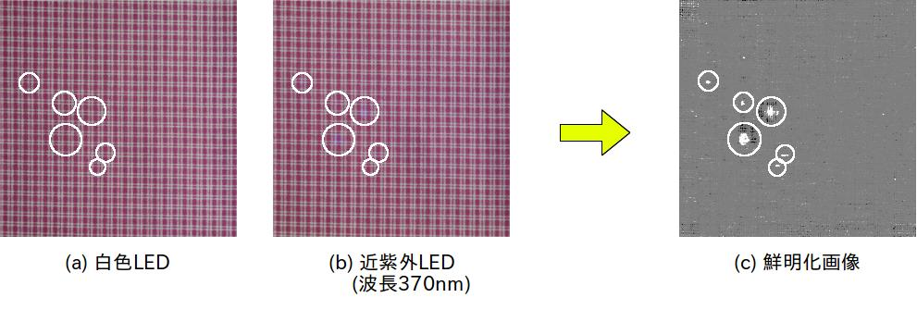
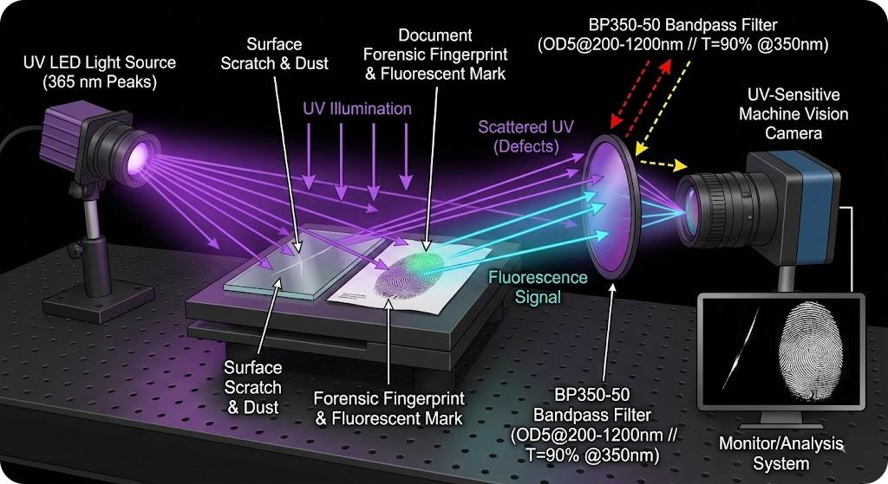
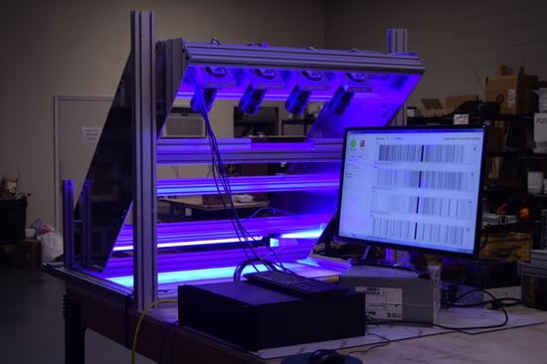UV illumination helps identify stains that are difficult to distinguish under normal visible light.
Working principle:
- UV illumination is directed towards the fabric.
- Certain stain materials may absorb UV radiation.
- They may produce different fluorescence responses.
- A suitable UV-sensitive camera or optical channel captures the response.
- Image-processing algorithms identify the stain regions.
An additional UV imaging channel can work alongside the existing visible-light camera.
The UV source, filters and camera must be selected according to the actual stain materials and their fluorescence properties.

4. Comparison of adaptation strategies
Parameter | Software changes | Component modification | Complete redesign
Feasibility | Low | High relative to other options | Limited by budget
Accuracy | Limited improvement | Good potential | Very high potential
Processing time | May improve slightly | Can improve with optimisation | Potentially very fast
Cost | Low | Medium | Very high
Implementation risk | Medium | Medium | High
Hardware changes | No | Selected components | Major changes
A. Retain the existing system
- Improve image-processing algorithms.
- Optimise defect classification.
- Reduce unnecessary image operations.
- Use region-of-interest processing.
Limitation: Software cannot recover details that the existing camera never captured.
B. Modify selected components
- Upgrade the camera to a higher-resolution line-scan camera.
- Introduce UV illumination.
- Add a suitable UV-sensitive imaging channel.
- Optimise the existing CPU-based software.
- Improve image compression and storage management.
Advantage: Improves defect visibility without replacing the complete system.
C. Complete redesign
- Introduce a high-speed industrial imaging system.
- Use multiple imaging channels.
- Implement advanced processing hardware.
- Introduce high-speed storage and communication.
Limitation: It may exceed the existing budget and requires additional hardware resources.

5. Recommended adaptation strategy
Recommended: Modify selected components
The most practical approach is to upgrade selected components while retaining the existing PC.
Reasons:
- It avoids replacing the entire system.
- A higher-resolution camera improves small-defect detection.
- UV illumination helps identify special stains.
- Optimised software reduces unnecessary processing.
- It reduces implementation cost compared with complete redesign.
However, the existing PC and budget may not support all new requirements simultaneously. Therefore, this approach is a compromise rather than a guarantee of full compliance.

6. Updated system block diagram
Moving Fabric (1.2 m/s)
Visible LED
Normal defects
UV Illumination
UV-visible stains
High-Resolution Line-Scan Camera + UV Imaging Channel
Existing 4-Core CPU – Optimised Processing
Defect Detection and Classification
Storage
Defect images
Network
Production monitoring
High-Speed Marking Mechanism

7. Changes required
Component | Required change
Camera | Upgrade to approximately 9000-pixel or wider line-scan imaging
Illumination | Add controlled UV and visible LED illumination
Processing | Optimise CPU algorithms and parallel processing
Software | Add UV stain classification
Storage | Improve compression and selective image retention
Network | Improve communication speed
Marking | Use encoder-based position tracking

8. Requirements that cannot realistically be guaranteed
The following requirements may not be achievable with the unchanged PC and budget:
- 0.4 mm defect detection: Requires much higher spatial resolution and suitable optics.
- UV stain detection: Requires compatible UV imaging hardware and illumination.
- 0.3-second processing: The existing 4-core CPU may not process the increased image volume quickly enough.
- Twice the production volume: Requires higher acquisition, processing and storage throughput.
- Maximum missed-defect rate of 2%: Requires extensive testing and validation.
There is also an important timing issue.
The marking mechanism is located 0.3 m downstream.
At the new speed:
\[ t=\frac{0.3}{1.2} \]
\[ \boxed{t=0.25\text{ seconds}} \]
Therefore, the decision and communication must be completed in less than 0.25 seconds, with additional time reserved for actuator response. A 0.3-second decision alone would be too slow for that marking distance.
Final conclusion: Modifying selected components is the most practical adaptation strategy. However, achieving every new requirement would realistically require additional processing capacity, a higher-resolution camera, UV imaging hardware and possibly an increased budget.

Overall conclusion
Computer vision provides an effective solution for automated textile defect inspection. Based on the original production requirements, the recommended system consists of:
Design parameter | Final recommendation
Inspection approach | Fully automated computer vision
Processing pipeline | Three-level pipeline
Image representation | RGB + HSV + Grayscale
Connectivity | 8-connectivity
Camera | Industrial line-scan camera
Image resolution | 2448 × 2048
Quantization | 12-bit acquisition
Image formation | Calibrated imaging
Illumination | Controlled LED
Processing hardware | 4-core CPU
Implementation | Balanced configuration
Total budget | ₹1,50,000

The original design offers a practical balance of defect-detection capability, processing speed, image quality and cost. For the new export order, selected hardware upgrades and software optimisation are necessary, although full compliance cannot be guaranteed under unchanged resource constraints.
Assignment tip: Include the numerical calculations in Tasks 6 and 7, and draw the block diagrams in Tasks 2, 9 and 10 neatly. These are important parts of the technical justification.

